# **Understanding the World**

* Keeping healthy and fit
* Similarities and differences between ourselves and our families
* Celebrating birthdays
* Name and identifying body parts/senses
* Learning about different types of fruit and vegetables that different countries use
* Learning about different places around the world.
* Diwali

# **Literacy**

* Phonics
* Letter formation
* Rhyming games
* HFW
* Intro to reading
* Writing opportunities in all areas

## Communication and Language

* Speaking and listening carpet time
* Story time
* Sharing our ideas with others
* Treasure boxes

**Expressive Arts and Design**

* Self portraits
* Paintings of our family
* Making music with our body parts
* Vegetable printing for harvest
* Making our own large and small scale 3D vehicles
* Role play
* Hand painting
* Clay modelling

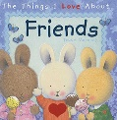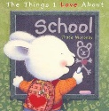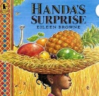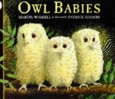

**Reception Autumn 1**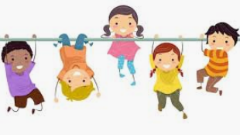

**What makes me so amazing?**

**Wheels or wings? What would you choose?**

**Book focus:**

**Don’t Forget:**

* As the weather gets colder please remember wellington boots (to stay in school), waterproof clothes and warm hats/gloves.

**Physical Development**

* Games –First Touch
* Ongoing provision inside and outside area for gross and fine motor activities
* Funky fingers
* Managing own personal hygiene and self care.
* Independent dressing and undressing.

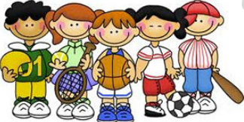

# **Mathematics**

* *Just like Me!*

Match and Sort

Compare amounts

* *It’s Me 1 2 3!*

Representing, comparing and composition of 1,2,&3.

* *Light and Dark*

Representing numbers to 10

**Personal, Social and Emotional Development**

* Forming good relationships with adults and peers
* Behavior expectations and routines
* Feelings games