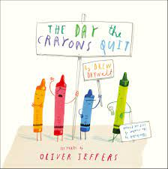

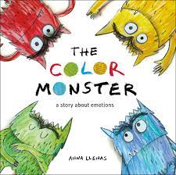

**Topic:**

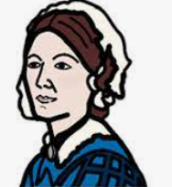

**History**: Our historical enquiry will centre on Florence Nightingale and her impact on the world of nursing.

We will find out why she went to Scutari and what conditions were like.

We will also explore the differences between

medicine now and then.

**Music:** Through the use of body percussion, tuned and untuned instruments, we will be composing our own musical scores. We will be using simple musical notation to compose.

**Art:**

We will be exploring printing techniques using rubbings, found objects and natural artefacts. We will look at the work of Orla Kiely and William Morris for inspiration.

**Science**

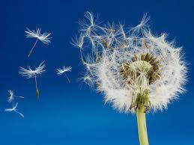

Plants continued.

We will learn the different methods that plants use to disperse their seeds.

We will look at plants that we eat and which part of the plant provides this food.

We will be sowing vegetable seeds and observing the growth as well as eating them!

**Class 2 Topic Web**

**Summer 1**

**Topic Focus: Healthy Minds and Healthy Bodies**

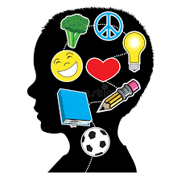

**English**

**:**

We will be reading ‘The Day the Crayons Quit’ by Drew Daywalt and Oliver Jeffers. Through this engaging text we will explore letter writing and expanded noun phrases. We will read Christina Rosetti’s poem ‘What is Pink?’ and use it as a stimulus for our own poetry writing.

‘The Colour Monster’ by Anna Llenas will lead us into more poetry writing using similes. This book links to our theme of healthy minds by exploring our feelings.

.

**Computing**

We will be exploring how music can be created digitally. We will make musical patterns involving rhythm, tempo and pitch, linking these compositions to our music curriculum.

R.E. Places of Worship

-

What makes a place special? We will find out about mosques, churches, gurdwaras and Hindu Temples.

**PSHE** Our topic will be ‘Growing Up’. We will be thinking about how our bodies and minds change over time.

.

**Maths**

We will be finding out about fractions, focussing on halves, quarters and thirds. This will involve finding a fraction of numbers and dividing shapes.

After fractions, we will be learning to tell and write the time to 5 minutes, including quarter past/to the hour. We will also be learning to know the number or minutes in an hour and hours in a day.

We will then move onto learning about mass, capacity and temperature. We’ll learn about cm/m, kg/g, L/ml. We will compare and order these standard units.

**P.E. and Games**

**:**

Friday: Games lessons

(

provided by PE Specialists)

Indoor P.E. Country Dancing -Gay Gordons, Circassian Circle and The Houlichan Roundabout.

